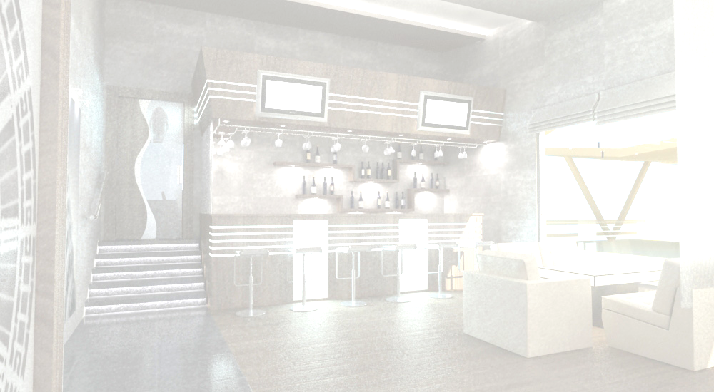  arayi |  |  |  |  |  | viski
Vodka |  |  |  |  |  | Whiskey
nemirovi |  |  |  |  |  | irlandiuri viski
Nemiroff |  |  |  |  |  | 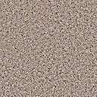Irish Whiskey
leqsi ultra | 0.7l. | 98.00 | lari |  |  |  | jemisoni |  | 50 mg |  | 7.60 |  | lari
LEX Ultra | 0.7 L. | 98.00 | GEL |  |  |  | Jameson |  | 50 Mg |  |  |  | GEL
leqsi | 0.5l. | 50.00 | lari |  |  |  | jemisoni 12 w.daZ |  | 50 mg |  | 9.80 |  | lari
LEX | 0.5 L. | 50.00 | GEL |  |  |  | Jameson 12 y.old. |  | 50 Mg |  |  |  | GEL
premiumi | 0.7l. | 28.00 | lari |  |  |  | buSmilsi 10 w.daZ. |  | 50 mg |  | 11.40 |  | lari
Premium | 0.7 L. | 28.00 | GEL |  |  |  | Bushmills 10 y.old. |  | 50 Mg |  |  |  | GEL
xorblis | 0.5l. | 17.00 | lari |  |  |  | kanaduri viski
Wheat | 0.5 L. | 17.00 | GEL |  |  |  | Canadian Whisky
xorblis | 0.25l. | 8.50 | lari |  |  |  | kanadian klabi 12 w.daZ. |  | 50 mg |  | 6.00 |  | lari
Wheat | 0.25 L. | 8.50 | GEL |  |  |  | Canadian Club 12 y.o. |  | 50 Mg |  |  |  | GEL
“beriozovaia” | 0.5l. | 17.00 | lari |  |  |  | qroun roial |  | 50 mg |  | 7.60 |  | lari
Birch | 0.5 L. | 17.00 | GEL |  |  |  | Crown Royal |  | 50 Mg |  |  |  | GEL
“beriozovaia” | 0.2l. | 8.00 | lari |  |  |  | amerikuli viski
Birch | 0.2 L. | 8.00 | GEL |  |  |  | American Whiskey
wiwakis | 0.25l. | 8.50 | lari |  |  |  | jek danielsi |  | 50 mg |  | 7.90 |  | lari
Pepper | 0.25 L. | 8.50 | GEL |  |  |  | Jeck Daniels |  | 50 Mg |  |  |  | GEL
staliCnaia |  |  |  |  |  | j.d. singl bareli |  | 50 mg |  | 9.80 |  | lari
Stolichnaia |  |  |  |  |  | J.D. Single Barrel |  | 50 Mg |  |  |  | GEL
“staliCnaia” | 0.5l. | 19.00 | lari |  |  |  | jim bim |  | 50 mg |  | 7.60 |  | lari
“Stolichnaia” | 0.5 L. | 19.00 | GEL |  |  |  | Jim Beam |  | 50 Mg |  |  |  | GEL
“staliCnaia” | 0.2l. | 9.00 | lari |  |  |  | jim bim Savi |  | 50 mg |  | 7.60 |  | lari
“Stolichnaia” | 0.2 L. | 9.00 | GEL |  |  |  | Jim Beam Black |  | 50 Mg |  |  |  | GEL
uSba |  |  |  |  |  | Sotlandiuri viski
USHBA |  |  |  |  |  | Skotch Whisky
marusia | 0.5l. | 30.00 | lari |  |  | j&b |  | 50 mg |  | 6.00 |  | lari
Marusia | 0.5 L. | 30.00 | GEL |  |  |  | J&B |  | 50 Mg |  |  |  | GEL
zelioni marka | 0.5l. | 12.50 | lari |  |  |  | balantaisi |  | 50 mg |  | 6.00 |  | lari
Green Murk | 0.5 L. | 12.50 | GEL |  |  |  | Ballantines |  | 50 Mg |  |  |  | GEL
uSba | 0.5l. | 8.00 | lari |  |  |  | Civas regali 12 w.daZ. |  | 50 mg |  | 9.90 |  | lari
USHBA | 0.5 L. | 8.00 | GEL |  |  |  | Chivas Regal 12 y.old. |  | 50 Mg |  |  |  | GEL
gomi |  |  |  |  |  | Civas regali 18 w.daZ. |  | 50 mg |  | 18.00 |  | lari
Gomi |  |  |  |  |  | Chivas Regal 18 y.old. |  | 50 Mg |  |  |  | GEL
elitaruli | 0.7l. | 30.00 | lari |  |  |  | Civas regali roial saluti |  | 50 mg |  | 48.00 |  | lari
Elite | 0.7 L. | 30.00 | GEL |  |  |  | Chivas Regal Royal Salut |  | 50 Mg |  |  |  | GEL
premiubi | 0.7l. | 24.00 | lari |  |  |  | j.v. wiTeli |  | 50 mg |  | 6.00 |  | lari
Premium | 0.7 L. | 24.00 | GEL |  |  |  | J.W. Red Label |  | 50 Mg |  |  |  | GEL
klasiki | 0.5l. | 15.00 | lari |  |  |  | j.v. Savi |  | 50 mg |  | 9.60 |  | lari
Classic | 0.5 L. | 15.00 | GEL |  |  |  | J.W. Black Label |  | 50 Mg |  |  |  | GEL
originali . | 0.5l. | 8.00 | lari |  |  |  | j.v. oqro |  | 50 mg |  | 12.60 |  | lari
Original | 0.5 L. | 8.00 | GEL |  |  |  | J.W. Gold Label |  | 50 Mg |  |  |  | GEL
“xlebni dari” |  |  |  |  |  | j.v. lurji |  | 50 mg |  | 55.00 |  | lari
” KhlebniDar” |  |  |  |  |  | J.W. Blue Label |  | 50 Mg |  |  |  | GEL
xorbali | 0.5l. | 17.00 | lari |  |  |  | daZvelebuli viski
Wheat | 0.5 L. | 17.00 | GEL |  |  |  | Single Malt Whisky
xorbali | 0.2l. | 8.00 | lari |  |  |  | glenmoranJi |  | 50 mg |  | 14.60 |  | lari
Wheat | 0.2 L. | 8.00 | GEL |  |  |  | Glenmorangie |  | 50 Mg |  |  |  | GEL
xortica |  |  |  |  |  | glenkiCi 12 w.daZ. |  | 50 mg |  | 13.60 |  | lari
Xortica |  |  |  |  |  | Glenkinchie 12y.o. |  | 50 Mg |  |  |  | GEL
xorbali | 0.5l. | 17.00 | lari |  |  |  | makalani 12 w.daZ. |  | 50 mg |  | 14.40 |  | lari
Wheat | 0.5 L. | 17.00 | GEL |  |  |  | The Macallan 12 y.o. |  | 50 Mg |  |  |  | GEL
xorbali | 0.2l. | 8.00 | lari |  |  |  | makalani 18 w.daZ. |  | 50 mg |  | 25.20 |  | lari
Wheat | 0.2 L. | 8.00 | GEL |  |  |  | The Macallan 18 y.o. |  | 50 Mg |  |  |  | GEL
berika |  |  |  |  |  |  | lafroidi 10 w.daZ. |  | 50 mg |  | 13.80 |  | lari
Berika |  |  |  |  |  |  | Laphroaij 10 y.o. |  | 50 Mg |  |  |  | GEL
berika | 0.5l. |  | lari
Berika | 0.5 L. |  | GEL
momsaxureoba-15 %
Service charge-15%

